California Short Wings September Chapter Report  
  
 The California Short Wings had their first meetup at KCPM on September 6th 2025. We’ve also got a website up and running at [CaliforniaShortWings.org](http://CaliforniaShortWings.org) and we’re hoping we can keep up one fly-in a month through the holidays. Here’s hoping!

For September we had Dan Busta fly in with his PA-22-150 from San Gabriel Valley (KEMT) and Josh Hinman fly-in also from San Gabriel Valley (KEMT) in his C182. Dan Patey is based at the field (KCPM) and walked over from his hangared PA-22-150.  
  
 EAA96 (eaa96.org) had an LAX tower controller talk basin operations, best practices for transitioning the bravo airspace, and plenty of anecdotes around working their way up through the various tower positions around the SoCal area.

After the talk the grill was fired up and burgers were enjoyed by all. Dan Busta drew quite the crowd with his PA-22 and described fun differences in PA-22s like Johnson bar breaks vs. toe brakes to the onlookers. Josh Hinman was giving demonstrations on his new panel and helped assist an RV owner with some trouble-shooting on a Garmin audio panel crackle issue (consensus was the culprit was the headphone jack grounds).  
  
 Afterwards the PA-22s took to the skies for some whale watching and a flight of 2 around the port of Los Angeles and Long Beach.

The LAX Controller drew a pretty good crowd and had lots of great information to provide on LA basin operations.

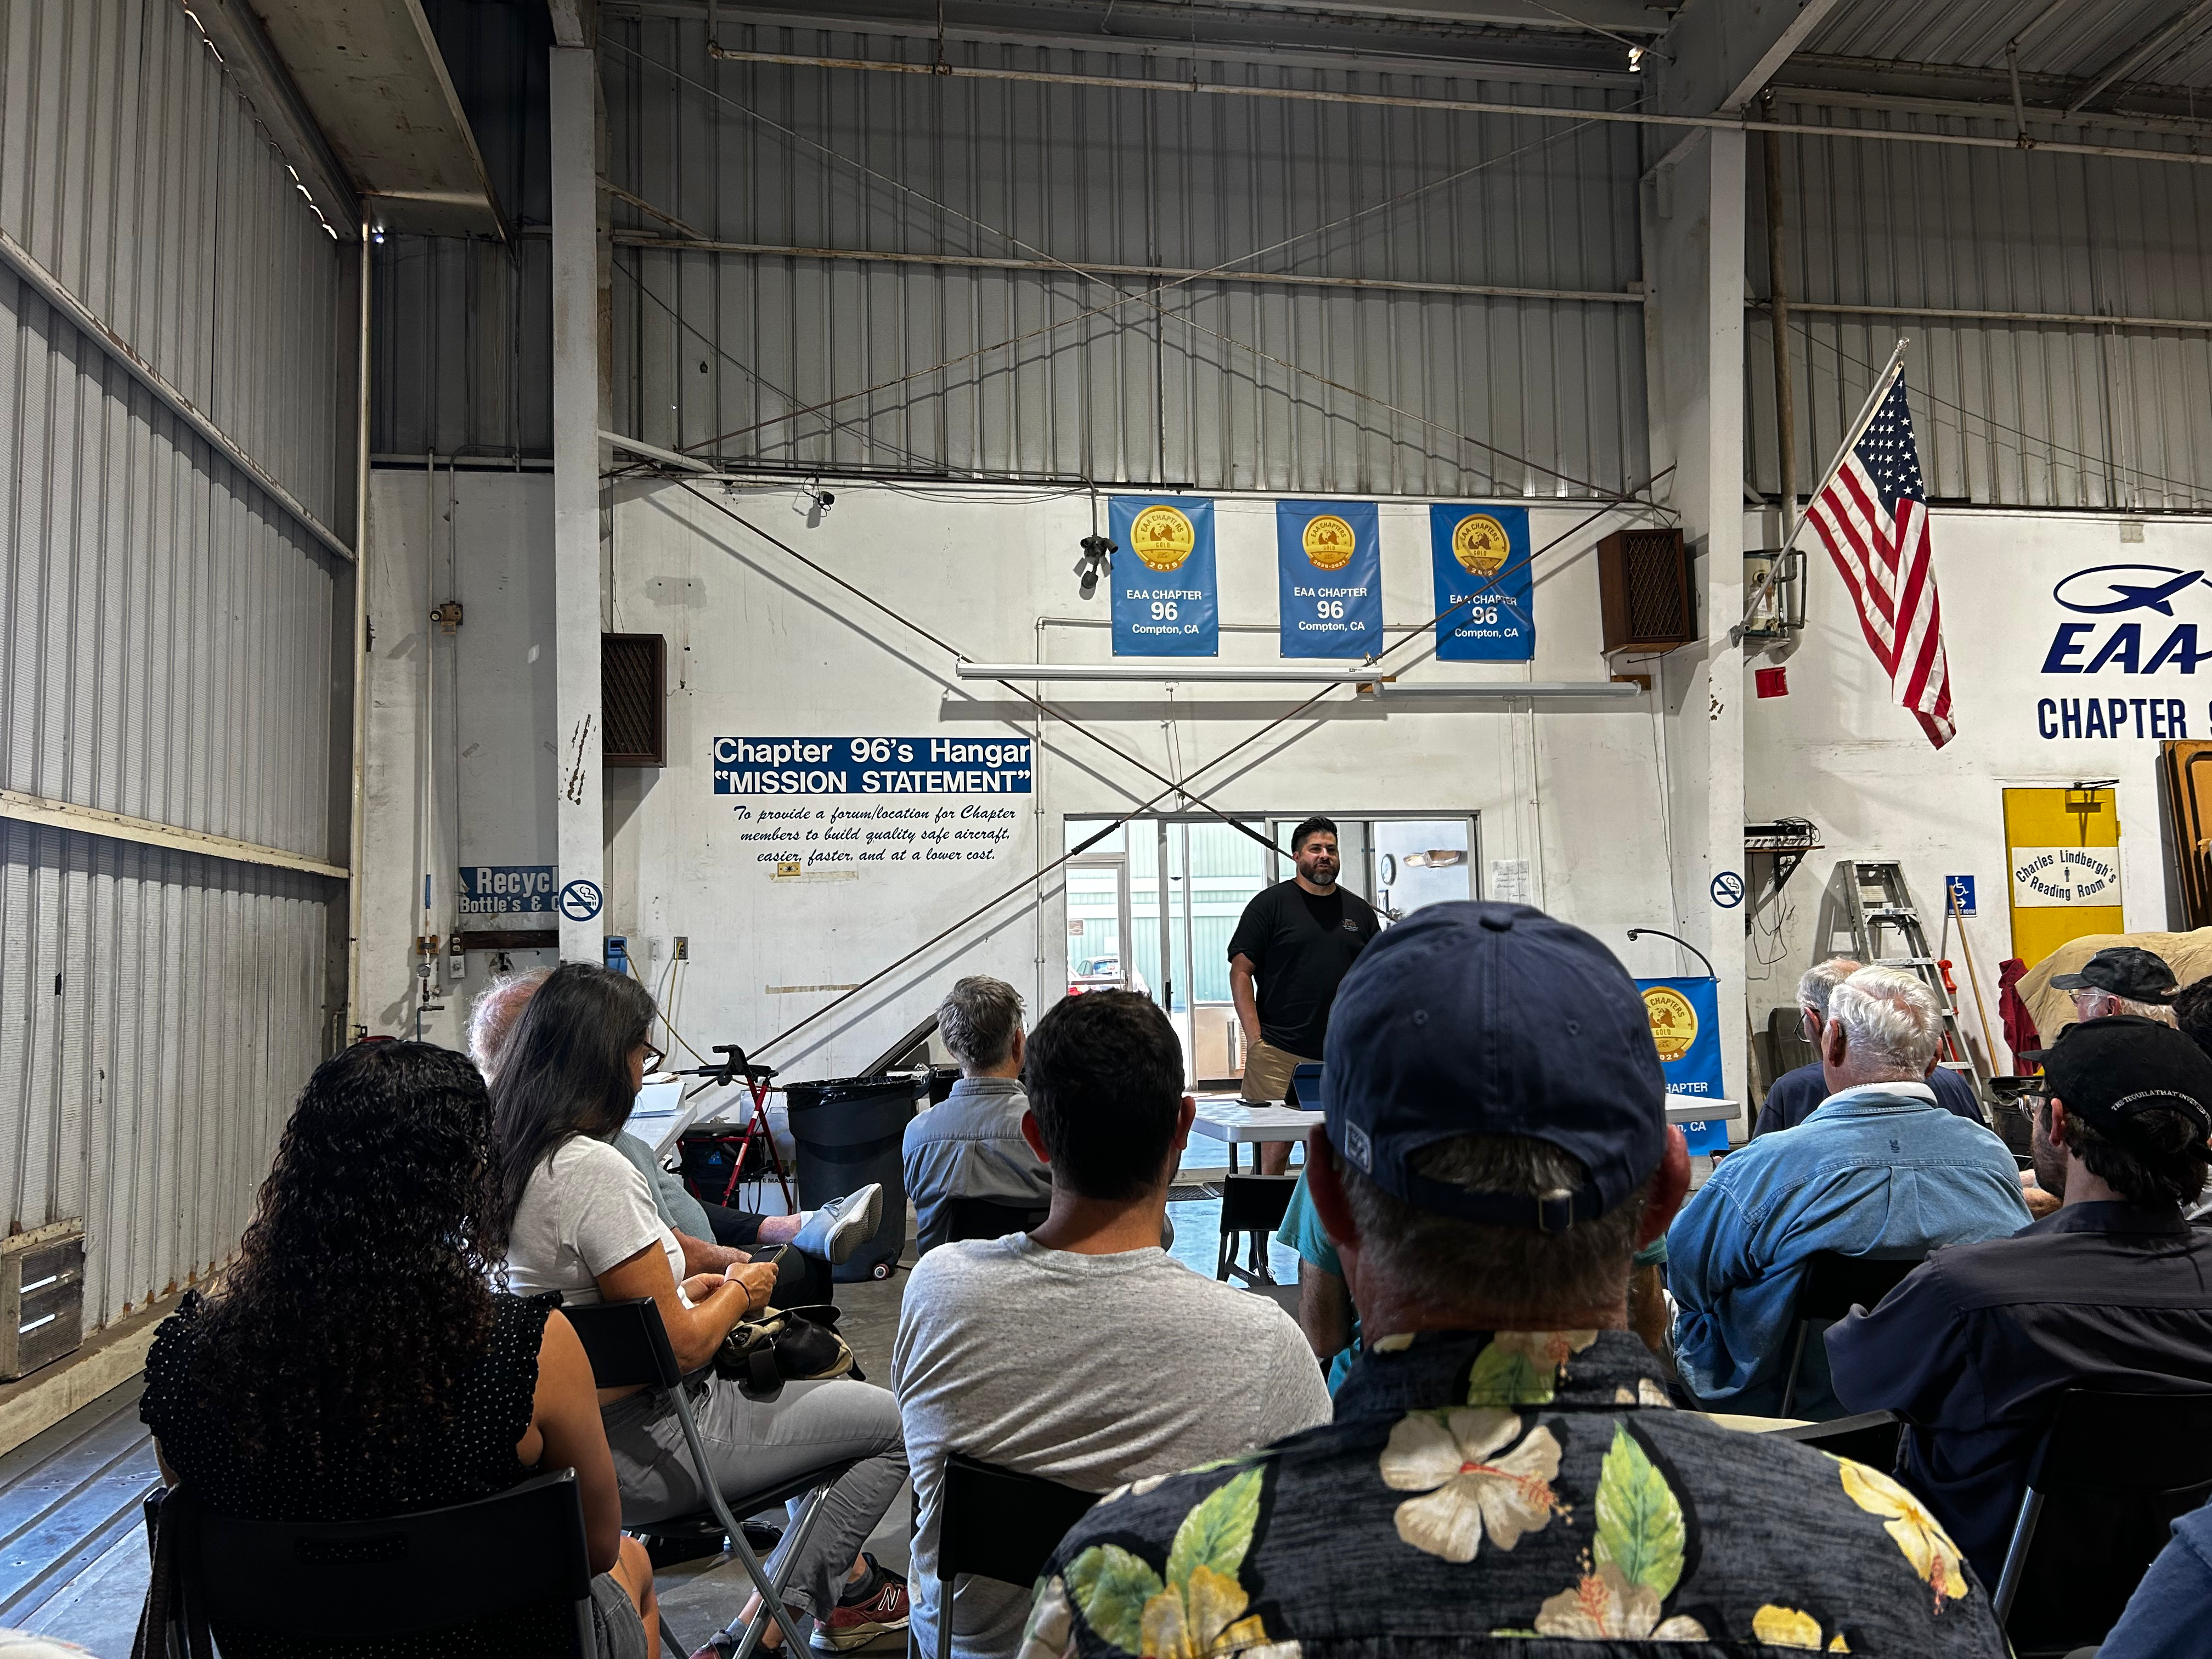

WINGS credit and a meet and greet afterwards as the 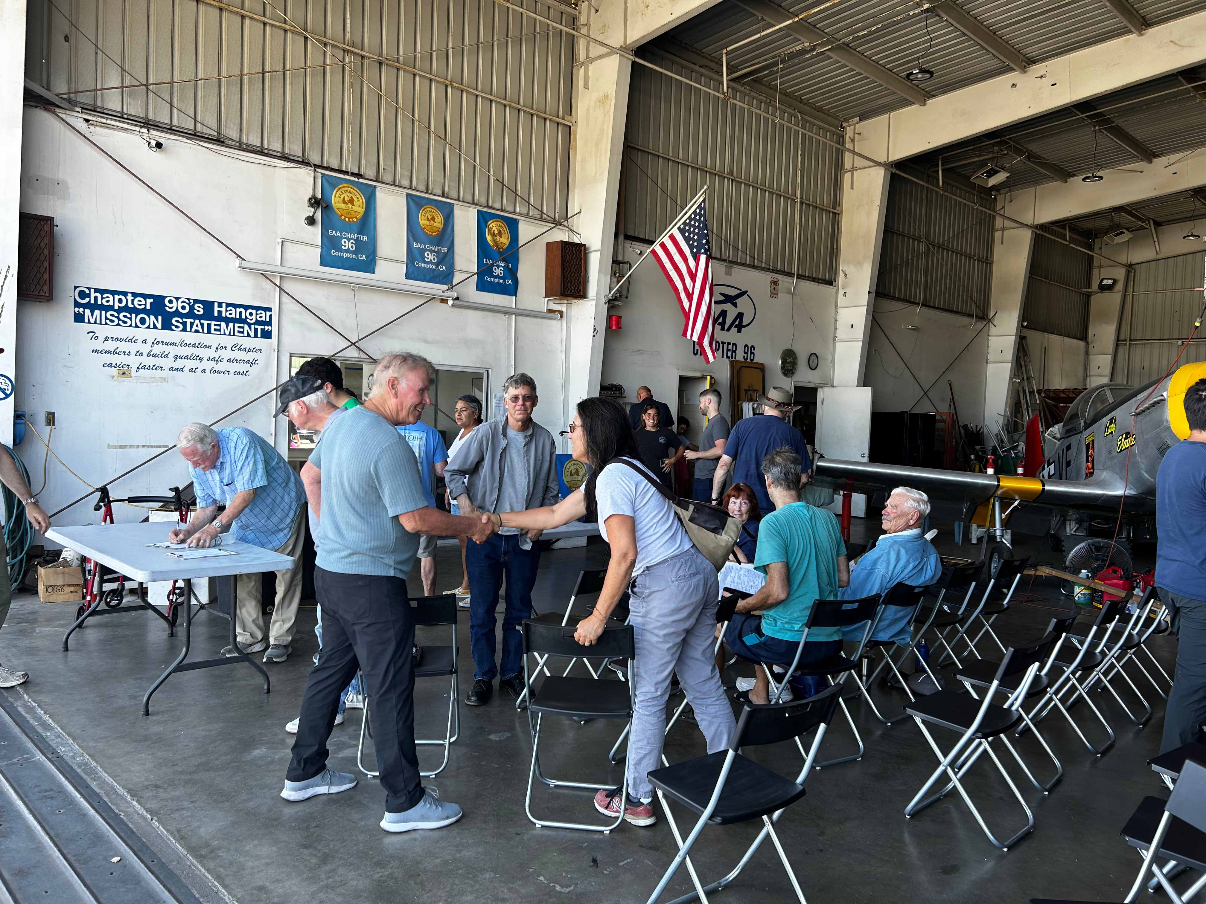grill was fired up for lunch.

Dan Busta flew in from KEMT in his PA-22-150 (a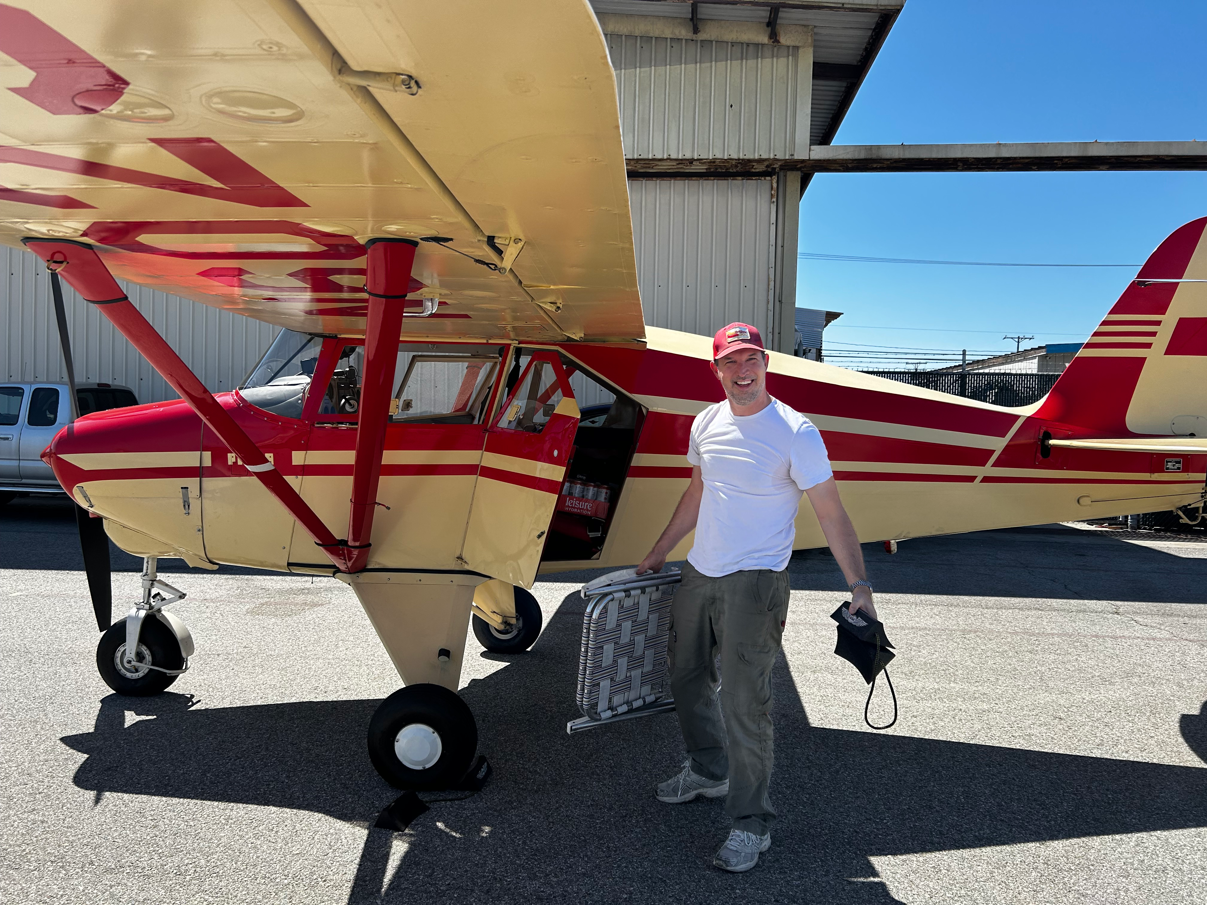nd brought his own chair!)

Josh Hinman flew in from KEMT in his C182 (an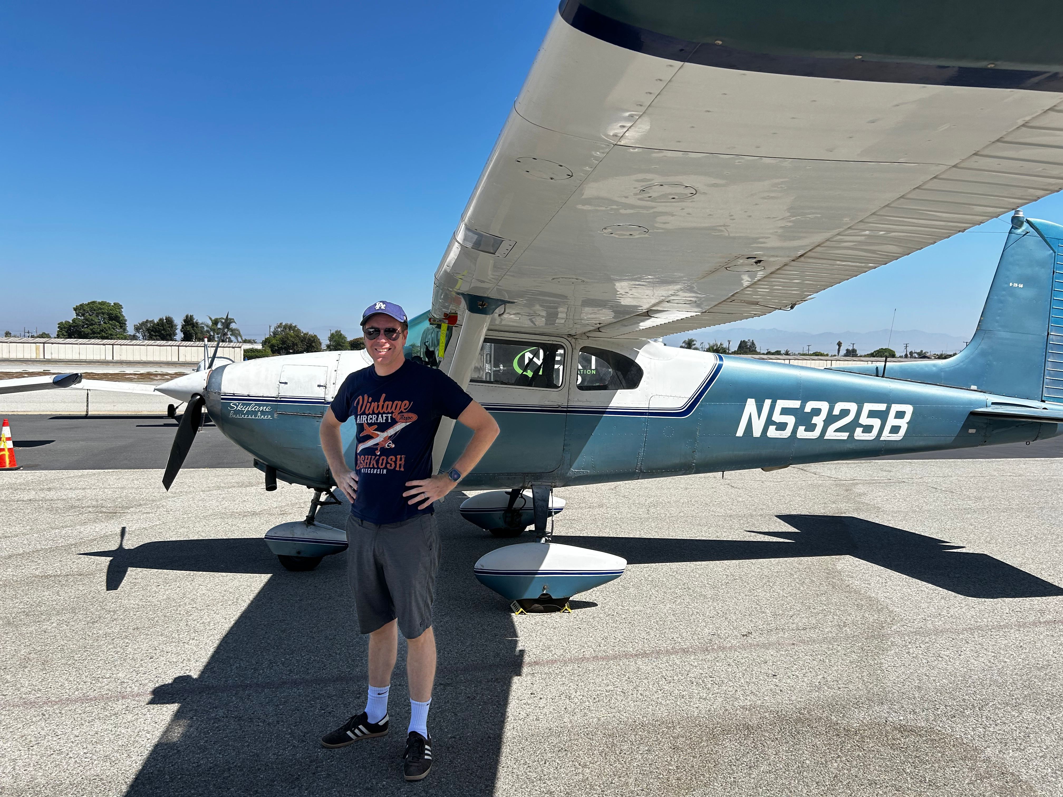d vintage EAA shirt!)

Dan Busta explaining the Johnson Bar brake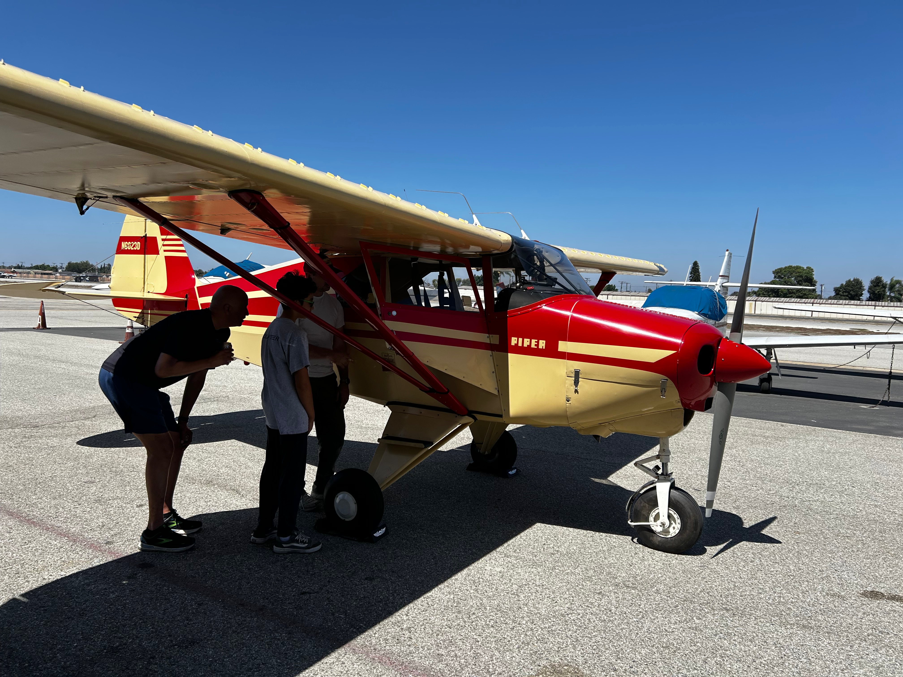s vs. toe brakes

The 22s head out looking for some oc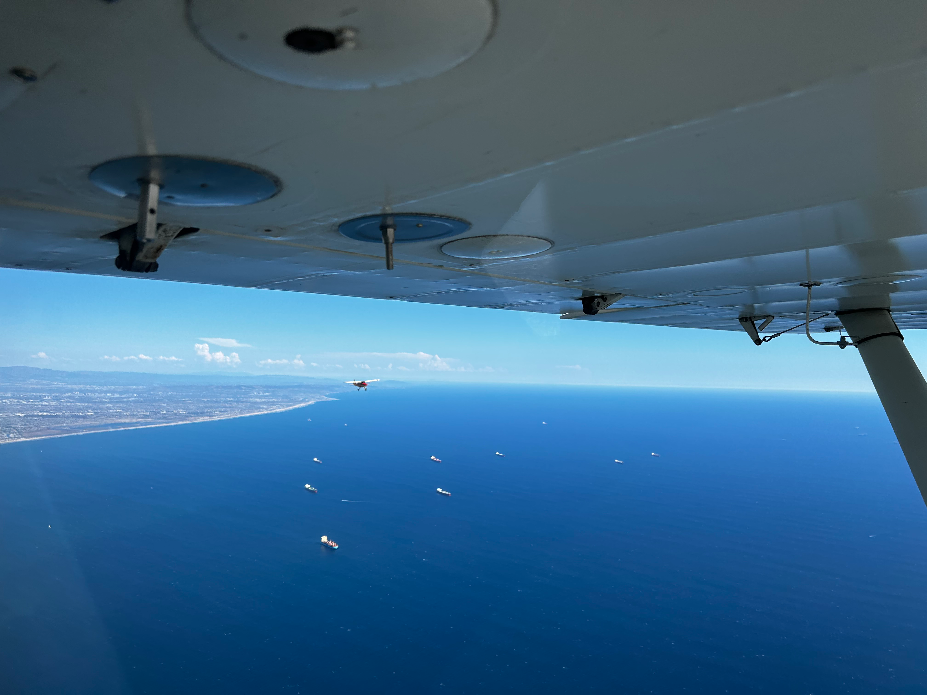ean wildlife.

The flight of 2 PA-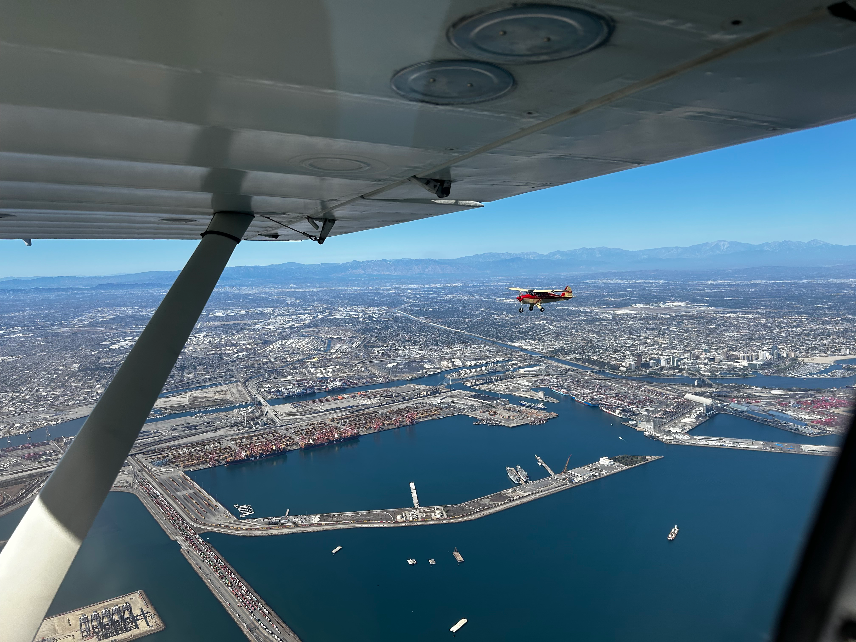22s took to the port.